**Big, Big, Big January Auctions Coming Up! BURCHARD GALLERIES AUCTIONS**

**January 11th, 25th, 26th, 2020**

**Over 1000+ Items from more than 20 Estates. Huge Fine Art Collection in this upcoming Auction, Vintage Period Antiques, Lladros, Stunning Estate Diamonds, Gold & Silver!**

**Come be a part of the Action! Consignments Welcome.**

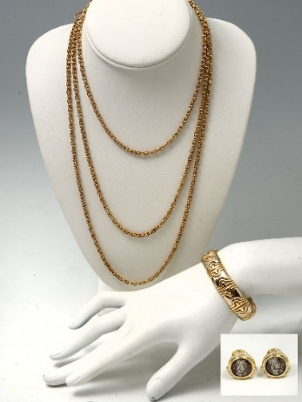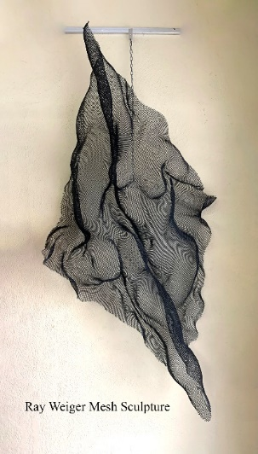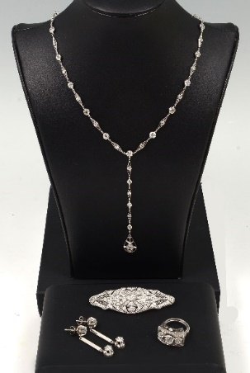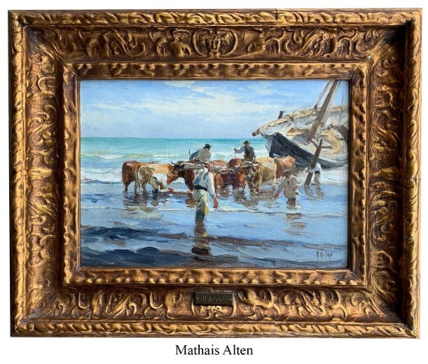

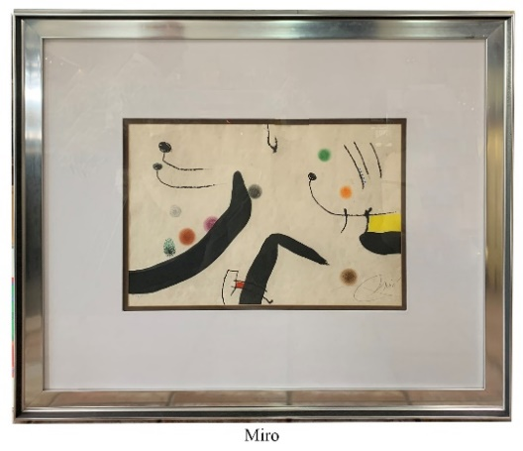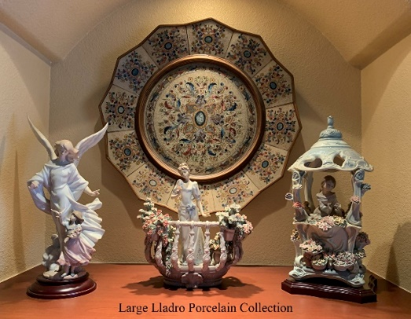

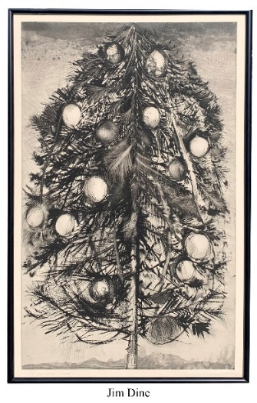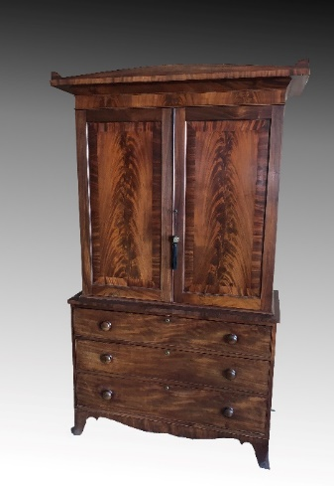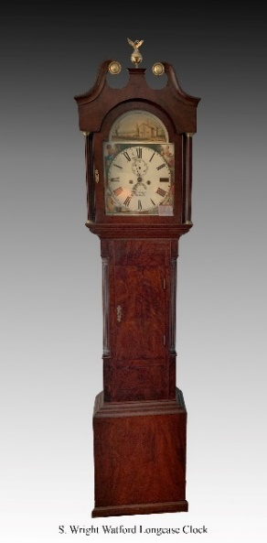

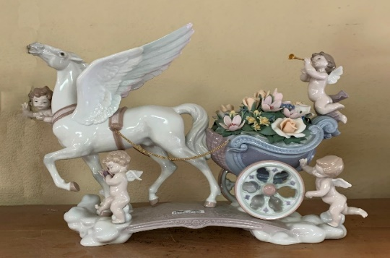

[**www.BurchardGalleries.com**](http://www.BurchardGalleries.com)

**mail@BurchardGalleries.com 727-821-1167**